> **restart:**

> **with(plots);**

Warning, the name changecoords has been redefined



vvod ishodnyh dannyh

F(u)=cosu, U0(x)=x,

> **F:=u->cos(u);**



> **U0:=x->x-1;**



>

rewenie uravneniya u-U0(x-F(u)*t)=0 pri t=0

> **implicitplot(u-U0(x)=0,x=-1..1,u=-1..1);**

> **A1:=implicitplot((u-U0(x-diff(cos(u),u)*0.1)=0,x=-1..2,u=-1..1),style=line,color=red):**

> **A2:=implicitplot((u-U0(x-diff(cos(u),u)*0.2)=0,x=-1..2,u=-1..1),style=line,color=blue):**

> **A3:=implicitplot((u-U0(x-diff(cos(u),u)*0.3)=0,x=-1..2,u=-1..1),style=line,color=yellow):**

> **A4:=implicitplot((u-U0(x-diff(cos(u),u)*0.4)=0,x=-1..2,u=-1..1),style=line,color=green):**

> **A5:=implicitplot((u-U0(x-diff(cos(u),u)*0.5)=0,x=-1..2,u=-1..1),style=line,color=orange):**

> **A6:=implicitplot((u-U0(x-diff(cos(u),u)*0.6)=0,x=-1..2,u=-1..1),style=line,color=black):**

> **A7:=implicitplot((u-U0(x-diff(cos(u),u)*0.7)=0,x=-1..2,u=-1..1),style=line,color=red):**

> **A8:=implicitplot((u-U0(x-diff(cos(u),u)*0.8)=0,x=-1..2,u=-1..1),style=line,color=blue):**

> **A9:=implicitplot((u-U0(x-diff(cos(u),u)*0.9)=0,x=-1..2,u=-1..1),style=line,color=green):**

> **A10:=implicitplot((u-U0(x-diff(cos(u),u)*1)=0,x=-1..2,u=-1..1),style=line,color=orange):**

> **A11:=implicitplot((u-U0(x-diff(cos(u),u)*1.1)=0,x=-1..2,u=-1..1),style=line,color=black):**

>

> **display({A1,A2,A3,A4,A5,A6,A7,A8,A9,A10,A11});**

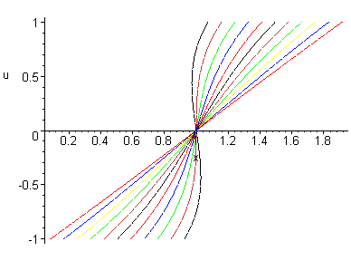

>

> Максимальное время равно 1